# 7 for 7 – 2018 Dodge Dynasty Champion Dave Nickelsen

Congratulations to Dave Nickelsen – the seventh different champion in the past seven seasons – for winning his first ever Dodge Dynasty League Championship! After a number of championship close calls ending in heartbreak, Dave finally cashed in with one of the unlikeliest runs ever. Five of his six keepers (OBJ, Freeman, Hunt, Wentz, & Gronk) were unavailable for the title game due to injury/ineffectiveness/unemployment. Only DeAndre Hopkins represented, leading a mishmash of Johnny-come-latelies including Chris Carson (Playoff MVP), Phillip Lindsay, Jaylen Samuels, Robert Foster, Mitch Trubisky, etc., all the way to a 94-83 victory!

The all-upset championship matchup featured the #5 seed Nickelsen squad, who knocked off Brian and newcomer Mike Kerkel, against #6 seed Jeremiah, who beat Jen and George, in a post-season tournament where chaos reigned supreme. In a rematch of the 2015 title game won by Jeremiah, Dave was able to exact some revenge and enter the win column. While one long-suffering Dynasty owner’s heartbreak finally ended, another (commissioner George Hawke) saw his continue. He now becomes the only original Dynasty owner to have never won a title. The league’s all-time leader in regular season wins, points, and years leading the league in scoring (4 of 11 seasons, including this year’s record 1466 points), the Hawkeman has been chewed up and spit out mercilessly in every post-season run, including this year’s near miss. Hang in there, me.

Thanks everyone for another exciting Dodge Dynasty season! Happy holidays and best of luck to all in 2019!

# **2018 Dodge Dynasty Awards**

**Dodge Dynasty MVP**

Winner: Pat Mahomes – Brian

Runner-up: Todd Gurley – Jen

**Playoff MVP**

Winner: Chris Carson – Dave

Runners-up: Matt Ryan – Jeremiah; DeAndre Hopkins - Dave

**Pickup of the Year**

Winner: Phillip Lindsay – Dave

Runners-up: James White – Brian; Eric Ebron – Jen; Bears D/ST - George

**Sleeper of the Year**

Playing for the team that drafted them

Winner: James Conner – Jeremiah

Runners-up: Nick Chubb – George; Aaron Jones – Dave; Tyler Lockett – Meat; Matt Ryan – Jeremiah

**Bust of the Year**

Non-Injury

Winner: Le’Veon Bell – Jay

**Bust of the Year**

Non-Diva

Winner: Rob Gronkowski – Dave

Runners-up: Jordan Howard – Pohlmann; Aaron Rodgers – Meat

**Rookie of the Year**

Winner: Saquon Barkley – Pohlmann

Runners-up: Nick Chubb – George; Phillip Lindsay – Dave; Baker Mayfield – Meat; Calvin Ridley – Jeremiah

**Comeback Player of the Year**

Winner: Andrew Luck – George

Runner-up: Adrian Peterson – Brian

**Breakout Player of the Year**

Non-Rookie

Winners: Pat Mahomes – Brian; Christian McCaffrey – Jay

Runners-up: James Conner – Jeremiah; Robert Woods – Jen

**Dodge Dynasty Owner of the Year**

Winner: Brian Kenderes

Runners-up: George Hayek, Mike Kerkel, Dave Nickelsen, Jen Hayek

**Denver Broncos Willis McGahee Award**

Not washed up yet

Winner: Drew Brees – Jen

Runners-up: Adrian Peterson – Brian; Tom Brady – Steve

**Cleveland Browns Willis McGahee Award**

“Now I’m done”

Winner: Brandon Marshall

Runners-up: Mark Sanchez

**Matt Breida Most Career-Ending Injuries in One Season Award**

Winner: Matt Breida – Brian

**Gritty, High-Motor, Lunch Pail Kinda Guy Award**

[Sneaky Athletic Grinder with Deceptive Speed and Intangibles](https://awfulannouncing.com/2014/your-white-guy-code-word-power-rankings.html)

Winner: Adam Thielen – Meat

Runners-up: Christian McCaffrey – Jay; Julian Edelman – Pohlmann; Cooper Kupp – Kerkel

# **Perfect Lineups**

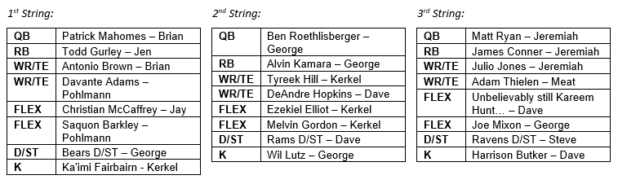

# **Next Year’s Draft Order**

Draft order for every round (excluding any 1st round comp picks)

1. Steve
2. Jay
3. Meat*
4. Pohlmann
5. Brian
6. Jen
7. George
8. Kerkel
9. Jeremiah
10. World Champion Dave

* Meat’s5th round pick traded to George

# **2018 Adjusted Total Points (used for Non-Playoff Draft Order)**

